Assignment No -: 12

Que 1 -: Write A Query that Selects all Customers Whose Ratings are equal to or greater than any of ‘Serres’.

kd2_83598>select Customers.Rating,Customers.Cname,Customers.Snum from Customers,salespeople
-> where Customers.Snum=salespeople.Snum and
-> Rating>=any(select Rating from Customers
-> where salespeople.Sname='Serres');

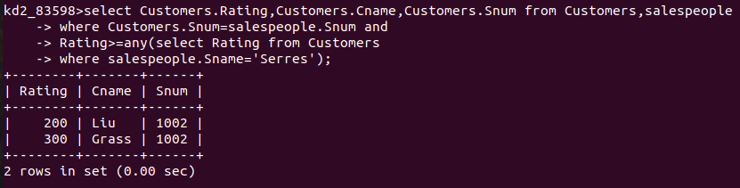
Que 2 -: Write A Query Using Any or All That will find all salespeople who have no Customers located in their city.

kd2_83598>select salespeople.Snum,salespeople.Sname from Customers,salespeople
-> where salespeople.Snum=Customers.Snum and
-> salespeople.Snum!=all(select Customers.Snum from Customers
-> where salespeople.city=Customers.city);

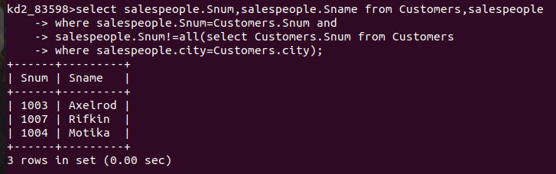

Que 3 -: Write a query That selects all orders for amounts greater than any for the Customers in london.

kd2_83598>select amt,snum,Cnum,onum from orders
-> where amt>any(select amt from orders
-> where Cnum in(select Cnum from Customers
-> where city='london'));

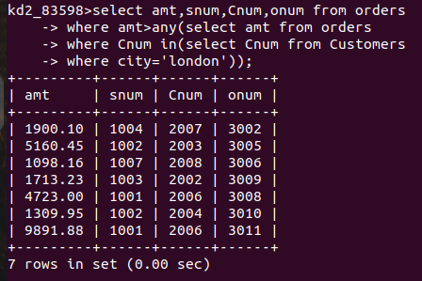

Que 4 -: Write The above Query using Min or Max

kd2_83598>select amt,snum,Cnum,onum from orders
-> where amt>any(select min(amt) min from orders
-> where Snum in(select Snum from Customers
-> where city='london'));
